10.98: The velocity of the center of mass will change by 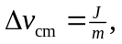 and the angular velocity will change by 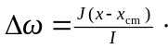The change is velocity of the end of the bat will then be 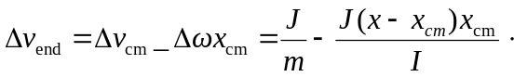 Setting 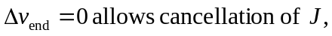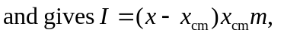which when solved for x is
